**Lesson 5 Demo 10**

**Understanding Pods Overheads and Performance Tuning**



Steps to be followed:

1. Defining resource requirements

**Step 1: Defining resource requirements**

1. Create a config file with the following command:

***vi singlepod.yaml***



1. Write the following code in the file:

***apiVersion: v1***

***kind: ResourceQuota***

***metadata:***

***name: webserver***

***spec:***

***hard:***

***cpu: "5"***

***memory: 10Gi***

***pods: "10"***

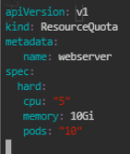

1. Write the following code to apply the changes:

***kubectl apply -f singlepod.yaml***





1. Write the following command to describe the pod to see the pod configuration:

***sudo kubectl describe pod webserver -n test***

